Practice Questions

MCQs

If 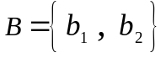 and 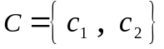 are two basis , let 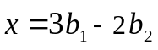 and 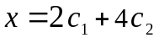 ; then which of the following is the value of 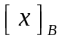?

(a) 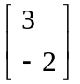
(b) 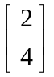
(c) 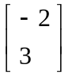
(d) 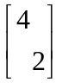

If 4 is an eigenvalue of A and x is a corresponding eigenvector, then the eigenvalue of A² is .....?

(a) 4
(b) 16
(c) 8
(d) 12

Short

Question No. 1. For the given matrix , find the eigenvector corresponding to the eigenvalue.
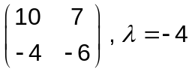 Answer = 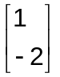

Question No. 2. Consider 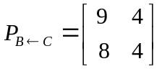 be the change-of-coordinate matrix from  to  ; then determine 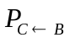 . Answer = 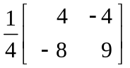

Question No. 3. Let 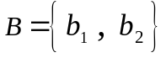 and 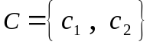 be bases for 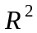 ; where 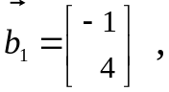 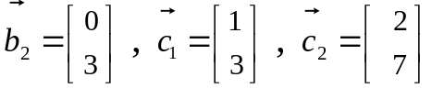 .
Find the change-of-coordinate matrix from to . Answer 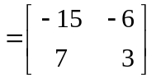

Long
Question No. 4. Let 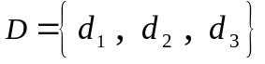 and 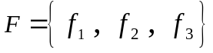 be bases for a vector space , also suppose that 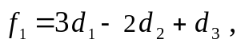 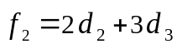 and 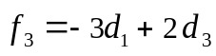 .

(a) Find the change-of -coordinate matrix from  to .
(b) Find the 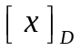 for 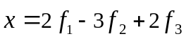 .

Answer= (a) 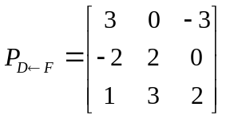 (b) 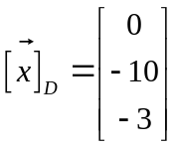

Question No. 5. Find a basis for the set of all solutions to the difference equation 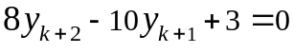.

Answer = Two solutions of the difference equation are 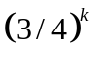 and 

